**STEPS FOR ADVANCE COUNTER**

1. Make the variable counter and grab the counter class from HTML. We made three counter class so to grab each of them we have to use for each function.

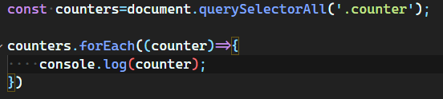

1. Now set default value of all counter class=0;

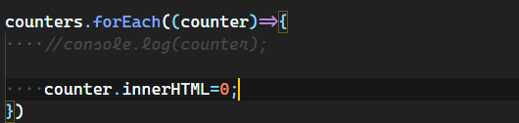

**Now we have to make the function (updateCounter) which helps to show the animation of incrementing number from 0 to target value (500);**

1. Now the grab the value of data-target from HTML

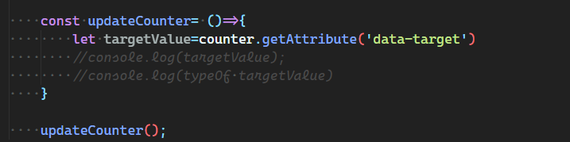

**#The data we get is in form of string but we need number.**

**There are three ways to convert string into number**

* **Using unary operator**

**var n= +str;**

* **Using number constructor**

**var n= Number(str);**

* **The parseFloat function**

**var n= parseFloat(str);**

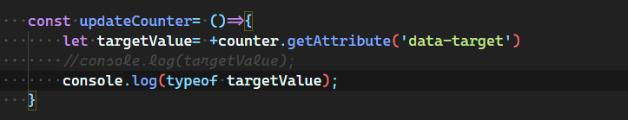

1. Now create the increment variable and assign it to targetcount/100;

Because we want to increment the startingCount in difference of 100

        const incr= targetcount/100;

1. Now check that startingCount is less than targetcount.

if it **true** then change the value of counter.innerHTML

and if it is **false** than set the value of counter.innerHTML  value equal to targetcount.

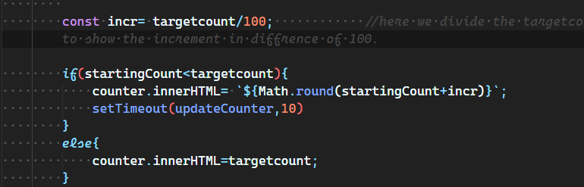

**#setTimeout is the only reason it is looking like animation.**

**Because it helps to execute function after waiting a specified number of milliseconds**

**UNDERSTAND THE FLOW OF CODE**

startingCount=0;

tragetcount=4000;

Now function start executing:

Const Incr= 4000/100; = 40;

If (startingCount (0) < targetcount (4000)) {

Counter.innerHTML= startingCount + incr; = 0+40=40;

setTimeout (updateCounter, 10); // it calls updateCounter function once again after 10 milliseconds. So Counter.innerHTML get increment by 40 every time till 4000;

}